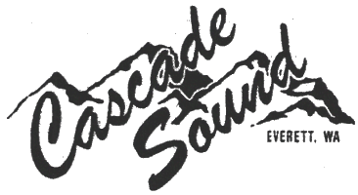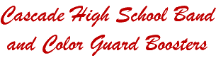

Dear Friends,
It is with great excitement that we invite you to participate in a very special event. Please partner with us in supporting “A Night of 150 Stars” Gala Dinner and Auction benefiting and celebrating the Instrumental Program at Cascade High School in Everett, Washington. Our auction will be held on Saturday, April 30, 2016 at the Edward D. Hansen Center at Xfinity Arena in Everett. This event is hosted by the Cascade High School Band & Color Guard Boosters and we are proud to be hosting this, our fourth auction.
The Cascade High School Band & Color Guard Boosters (Boosters) is a non-profit 501(c)(3) parent volunteer organization. For over 20 years the Boosters have worked tirelessly to raise funds to support and enhance the Band Program at Cascade High School. Our auction is a vital fundraising event whose proceeds ensure that the Boosters can continue to provide the financial support necessary for Cascade’s Band Program to maintain its high level of music education excellence. Funds raised from this auction directly impact this program by defraying program costs and fees and funding program needs and expenses. By defraying program fees, the band program will become more accessible for students who otherwise would not have the opportunity to participate in this enriching band program. Over 160 Cascade students participate in one or more of the following bands - Marching Band and Color Guard, Concert Band, Symphonic Band, Wind Ensemble, Percussion Ensemble, and Jazz Band.
Here is how you can help:
- Please consider donating an item to the silent auction. Some items that have sold well in the past include gift certificates, products that showcase your business, or coupons for upgraded services. We also welcome any cash donations made on behalf of yourself and/or your business. All donations made to our auction are tax deductible. A donation form has been enclosed for your convenience. We do ask that your donation be made no later than April 15, 2016.
- Please mark your calendars and plan to attend the auction on April 30, 2016. Celebrate with other generous community supporters while enjoying entertainment by our award winning Cascade High School Jazz Band. Email us at secondvicepresident@cascadebands.com for more information.
Thank you in advance for your support of this important event. Please know that your generosity will not only help preserve the excellent music education opportunities for the band students at Cascade High School, but will also sustain the link between high quality schools and the community.
With kindest regards,

Laura Allen
“A Night of 150 Stars” Auction Chair
2nd Vice President, Cascade High School Band & Color Guard Boosters

